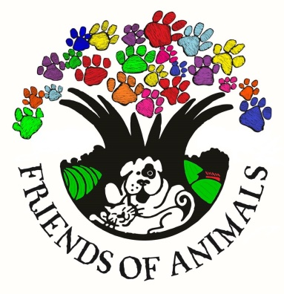
Friends of Animals
1980 Fayetteville HWY
Lynchburg, TN 37352
931-434-7508
friendsofanimalsraac@aol.com

CAT ADOPTION APPLICATION
***All questions are to ensure the pet is a good fit for you/your family.***

Cat Name: _____________________________________
Name: ______________________________________________________ DOB: _____________________
Co-Applicant Name: ____________________________________________ DOB: _____________________
Home Address: _____________________________________________________________________________________
City: _____________________________________ State: ____________________ ZIP: ________________
Home Phone: __________________________________ Cell Phone: _____________________________
Employer: _________________________________________________ Phone: ______________________________
How long have you worked at your current job?: __________________
How long have you lived at your current address?: _________________ RENT OWN
If you rent, do you have permission to have a cat?: YES NO
Landlord’s Contact Info: ______________________________________________________________________________
Have you or any family/household members been charged with animal cruelty? YES NO
Please briefly explain why you want a cat.: _______________________________________________________________
__________________________________________________________________________________________________
Is everyone living in your home in agreement on adopting a cat?: YES NO
Do you have children/plan to have children? YES NO
If you have children, please list their ages.: _______________________________________________________________
Please list all other members of your household, along with ages.: ____________________________________________
__________________________________________________________________________________________________
Who will be the primary caretaker of the cat?: ___________________________________________________________
Is anyone in your household allergic to cats?: YES NO
May we visit your home before and after adoption? YES NO
Do you currently have other pets?: YES NO
If yes, please list gender, breed, and age of current pets.: ___________________________________________________
__________________________________________________________________________________________________
Are current pets vaccinated annually?: YES NO
Spayed/Neutered?: YES NO
FELV/FIV neg? (Cats only): YES NO

Have current pets been around other animals?: YES NO
Do they get along with other animals?: YES NO
Do current pets have any serious medical issues?: YES NO
Please list all pets you have owned in the past 5 years. Include breed, sex, spayed/neutered and why you no longer have the pet.: ___________________________________________________________________________________________
____________________________________________________________________________________________________________________________________________________________________________________________________
Do you have a current veterinarian?: YES NO
If yes, Please list name, address, phone number and how long you have been a client.: ____________________________
____________________________________________________________________________________________________________________________________________________________________________________________________
Please contact the vet office and let them know a FOA representative may be calling to verify this information.
Where will the cat stay during the day/night?: ____________________________________________________________
How many hours will the cat be left alone on a regular basis?: _______________________________________________
How often do you travel?: ____________________________________________________________________________
Where will the cat stay if you are away for an extended period of time (vacation,etc.)?: __________________________
How will you handle destructive behavior if such problem occurs?: ___________________________________________
__________________________________________________________________________________________________
How will you handle litterbox training and/or problems?: ___________________________________________________
__________________________________________________________________________________________________
If you move, what will you do with the cat?: _____________________________________________________________
__________________________________________________________________________________________________
What would cause you to give up ownership of the cat?: ___________________________________________________
__________________________________________________________________________________________________

Please provide contact information for (2) non-relative reference.
- ______________________________________________________________________________________________________________________________________________________________________________________
- ______________________________________________________________________________________________________________________________________________________________________________________

How did you hear about us?: __________________________________________________________________________

By signing below, I am attesting to the truthfulness of my answers and information. Falsification of any of the above information will be grounds for dismissal of my application and possible removal of the pet from my home. Applicant must be 18 years of age or older. MCFOA reserves the right to refuse any applicant.
You will be contacted within 2 business days of application deadline if you are approved for adoption.

Signature: _______________________________________________________________________
Co-Applicant Signature: ________________________________________________________________
Date: ____________________________________

